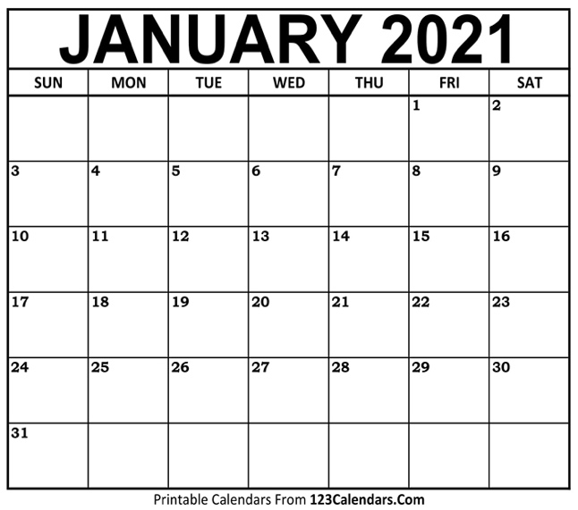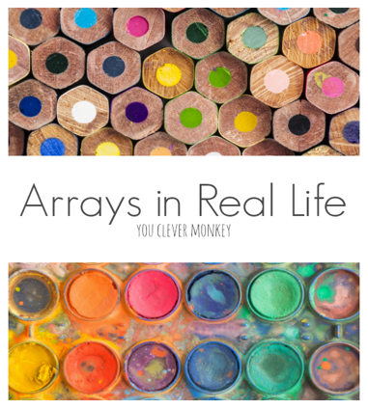

?

?, ? .

?

***Patterns:*** what comes next?

***Shape***: guess the shape.

3D shape

12 straight sides

6 faces which are all the same…

***Addition/Subtraction:*** Choose your challenge:

**12 + 9 =**

**21 - 7 - 6 =**

**28 + 9 - 15 =**

***Calendar:***

***Today is Wednesday 20th January. It is my brother’s birthday in 11 days. What date will that be on?***

***Multiplication:*** Choose your challenge

**8 x 2 =**

**4 x 5 *=***

**9 x 3 =**

***Use arrays to help you. For example,***

***2 x 6 = 12***

***2 rows of 6***

***paint pots***