Write 4 adjectives to

describe this picture.

Create a title for the picture

______________________________

**Quick write activity: Amazon rainforest**

|  |  |
| --- | --- |
|  |  |
|  |  |

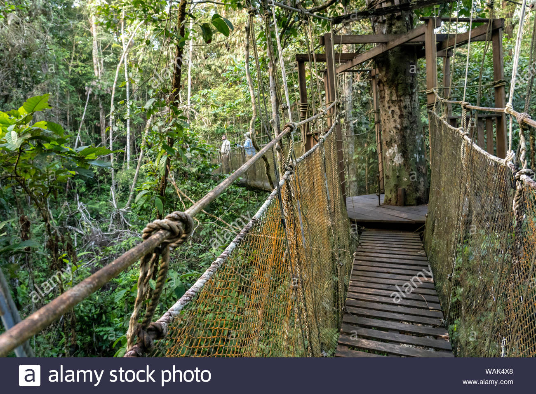

Give your opinion…

Would you walk across this bridge?

Yes or No? Why?

____________________________________________________________________________________

Write 3 sentences about this picture (try to add in your chosen adjectives).

________________________________________________________________________________________________________________________________________________________________________________________________________________________