**Quick write activity: Monkey Puzzle.**

Write 4 adjectives to

describe this picture.

Create a title for the picture

______________________________

|  |  |
| --- | --- |
|  |  |
|  |  |

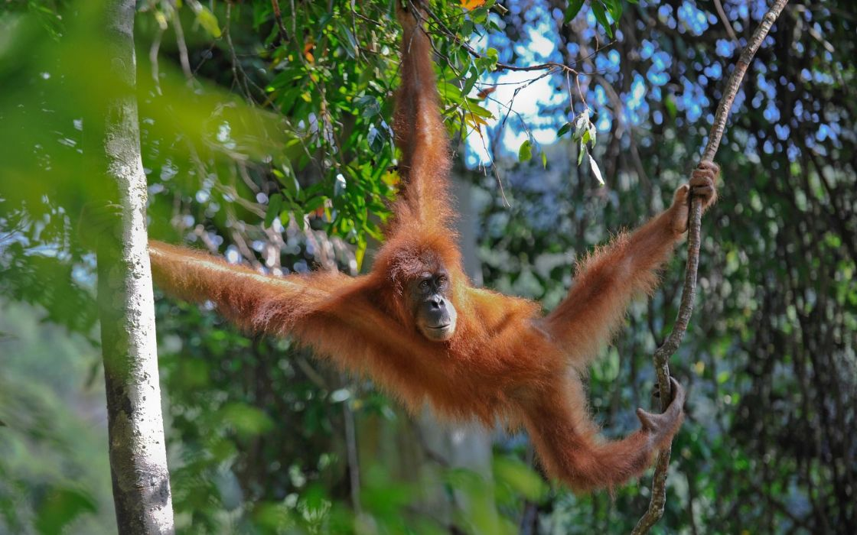

Give your opinion:

Would you like to swing from the trees to get around like Monkey’s do?

Yes? No? Why?

Would it be easy or hard? Tiring? Fun?

____________________________________________________________________________________

Write a short piece about this Monkey. Give him a name, where is he going? Why? What does he want?

*For example: Berny likes to swing from tree to tree. He quickly searches for golden banana’s as he goes by.* ________________________________________________________________________________________________________________________________________________________________________________________________________________________