**Quick write activity: Rumble in the Jungle.**

Write 4 adjectives to

describe this picture.

Create a title for the picture

______________________________

|  |  |
| --- | --- |
|  |  |
|  |  |

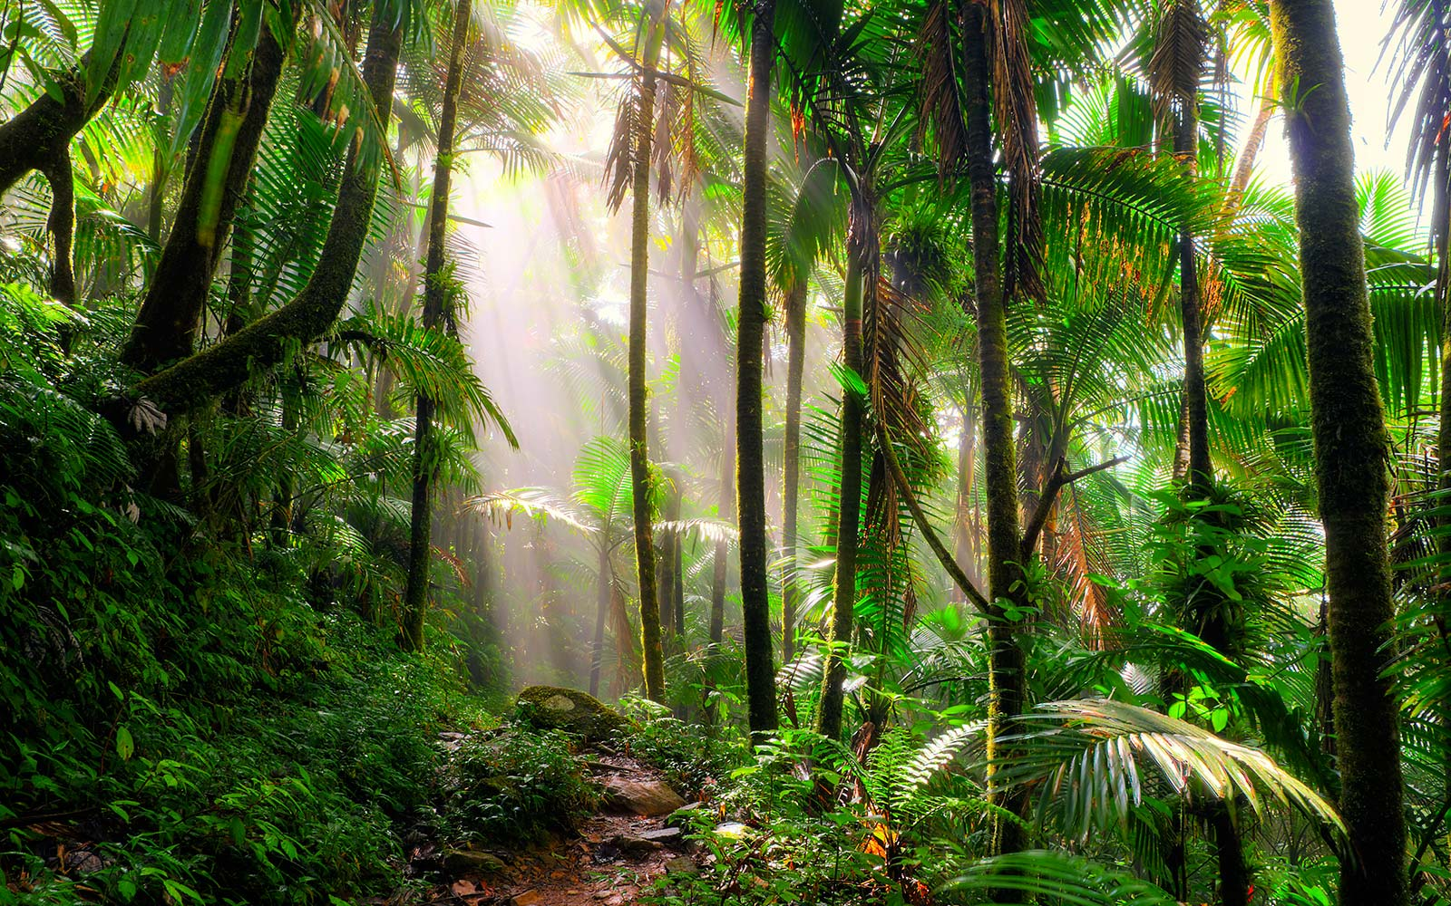

Write a sentence including an adverb. (Adverb: describes a doing word. ‘He ***quickly*** ate his dinner’.

quickly loudly happily carefully

quietly angrily softly excitedly.

____________________________________________________________________________________

Write an opening sentence to a story about this picture.

*For example: As my eyes peered open, through the* ***bright*** *sunlight, all I could see was* ***green*** *everywhere!*

________________________________________________________________________________________________________________________________________________________________________________________________________________________