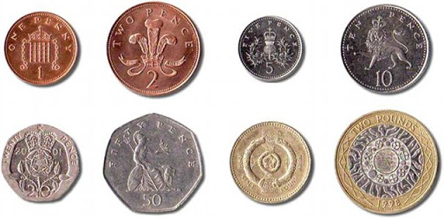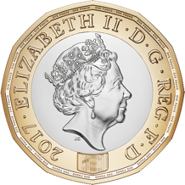

***Addition/ Subtraction:*** Choose your challenge:

**15 + 9 =**

**13 + 8 - 3 =**

**32 – 7 + 5 =**

**Division***(or use wording like share out ? sweets – using circles/teddies/people etc or use the timetables…):*

***10* ÷ 2 =**

***18* ÷ 3 =**

***32* ÷ 4 =**

**Today is Wednesday. Andrew is going swimming in exactly 1 week. What day will that be?**

***Shape: Name this shape….***

***Money: make 78p***