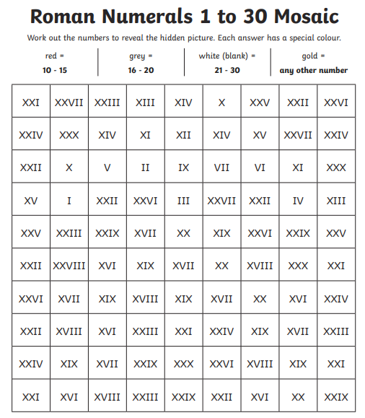

**Roman Numerals 1 – 30 mosaic**