We are learning about the Romans towns across Britain.

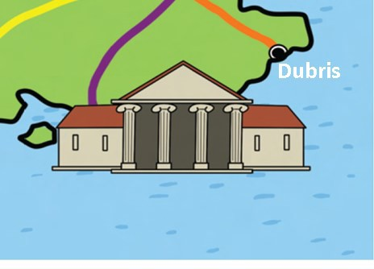
Look at the map showing ancient Roman towns. Use a map, see if you can solve the mixed-up Roman towns.

veda _______________
leravumium _______________
cisa _______________
dinlonmiu _______________
nonvesi _______________
cboeuram _______________

Extension: Could you find out the what the Roman town names are called now?

Roman Towns in Britain

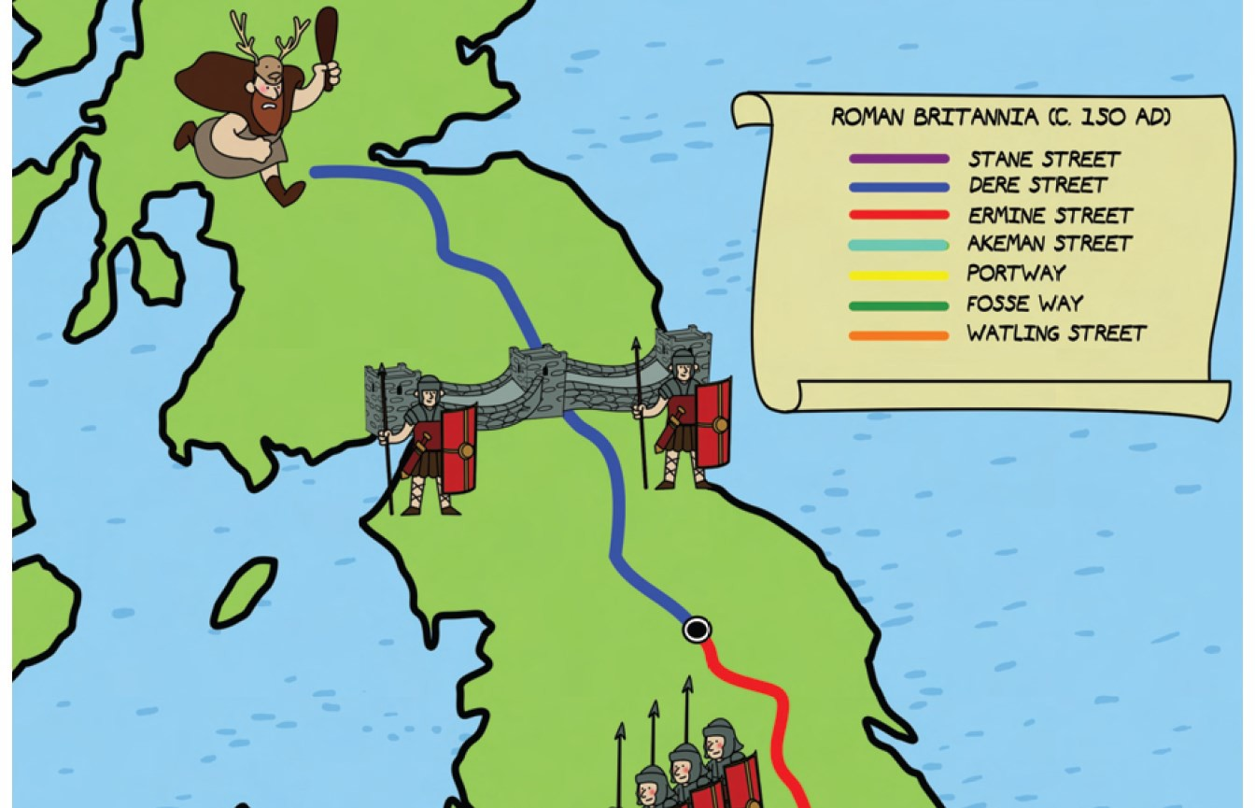
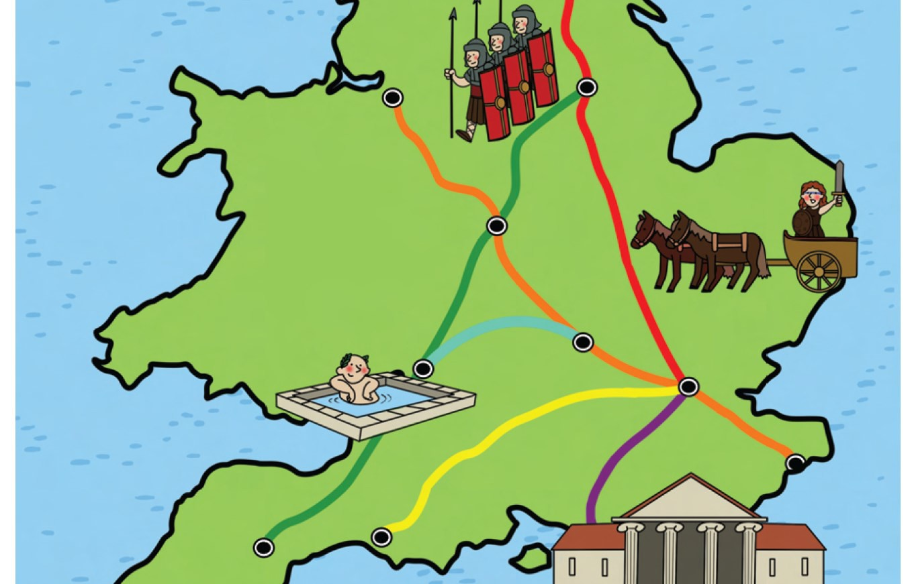
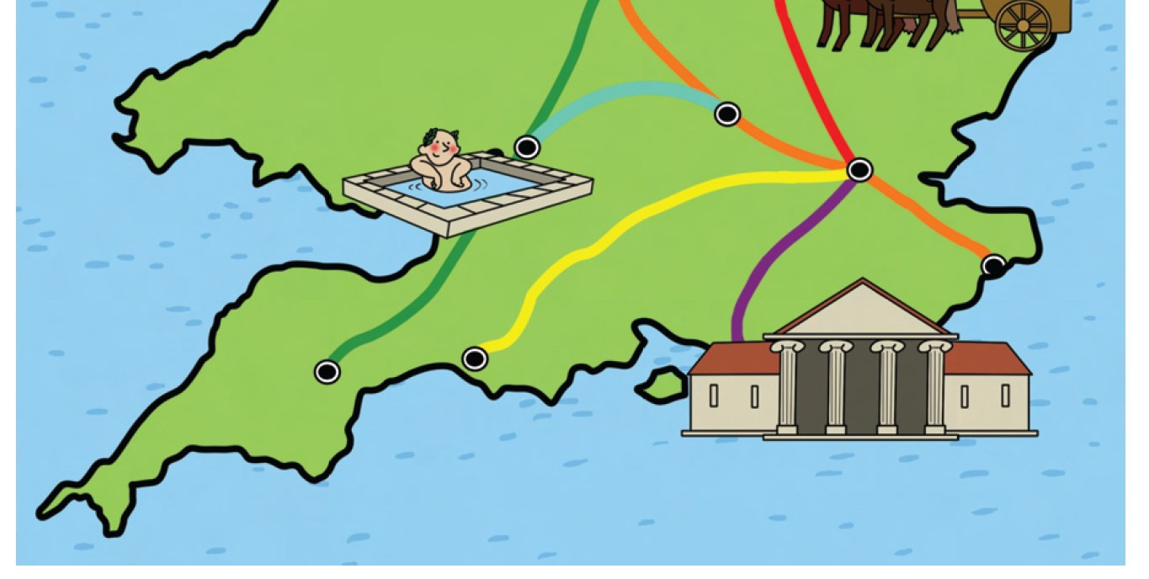
Eboracum

Lindum
Deva

Venonis

Aquae Sulis

Verulamium

Londinium

Dubris

Isca

Durnovaria

We are learning about the Romans towns across Britain.

Use the map showing the Roman towns and roads to answer these questions.

Which route would you take to get from:
Lindum
Hadrian’s Wall

Londinium
Dubris

Deva
Aquae Sulis

Aquae Sulis
Eboracum

