- 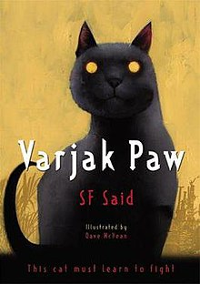
The Seven Skills of Jalal Paw
The Seven Skills are: Open Mind, Awareness, Slow-Time, Hunting, Moving Circles, Shadow Walking and Trust Yourself.

- Varjak Paw, a very young kitten and the main protagonist of the story
- Jalal the Paw, A Mesopotamian blue cat who ventured out into the Outside and found a home with the Countessa.
- Elder Paw, Varjak's grandfather and one of the few who remembers (part of) The Way of Jalal
- Sally Bones, the mysterious white cat who lords over the West Side of the city. She knows "The Way"
- Razor, Sally Bones' lieutenant
- Ginger, the ruler of the East Side of the city
- The Contessa, The old woman who owns the family of Jalal
- The Gentleman, a mysterious man who appears one day at the Contessa's house
- The Black Cats, two black cats that accompany The Gentleman; perfect fighting machines that are almost invulnerable
- Cludge, a dog who Varjak meets and who saves him from the Gentleman
- Julius Paw, Varjak's older brother
- Father, Son of Elder Paw, Father of Jay, Jerome, Jethro, Julius, and Varjak
- Aunt Juni, Mother to Jasmine, Aunt to Jay, Jethro, Jerome, Julius, and Varjak
- Mother, Mother of Jay, Jethro, Jerome, Julius and Varjak
- Holly, Varjak's future mate.
- Tam, a tabby cat and Holly and Varjak's best friend
Varjak Paw's name is an allusion to the film Breakfast at Tiffany's. In the film, one of the main characters, Paul Varjak, has written a book called "Nine Lives". When he and another character look for the book in the library catalogue, it is listed as "Nine Lives by Varjak, Paul". S.F. Said is not known to have commented on this connection.

