Homework: 30.11.18
Maths: |  | English:
Mathopoly!  Today you have a copy of the Mathopoly game we have been playing in class to take home. Have fun playing it. It’s a great way to learn and memorise your times table facts. |  | Adverbs:  Adverbs are words that describe how something is done and usually go after the verb (doing word).  Can you choose 5 of these adverbs and write your own sentences using them.  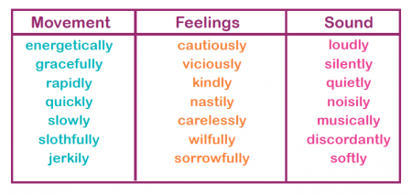
Spellings: Un- prefix
Group 1 | Group 2 |  | Group 3 | Group 4
Unlike  Unkind  Unable  Unfair  Uneven  Uncooked | Uncover  Unhappy  Unlucky  Unwrap  Unusual  Unbroken |  | Unafraid  unhealthy  Unequal  Unknown  Unselfish  Unfasten | Uncertain  Unfamiliar  Unknowable  Unimaginable  Unsurprisingly  Unconvincing
This week’s Science spellings:  impermeable  semi-permeable  permeable |  |  | This week’s maths spellings:  multiply  multiplication  partitioning
Homework: 30.11.18
Maths: |  | English:
Mathopoly!  Today you have a copy of the Mathopoly game we have been playing in class to take home. Have fun playing it. It’s a great way to learn and memorise your times table facts. |  | Adverbs:  Adverbs are words that describe how something is done and usually go after the verb (doing word).  Can you choose 5 of these adverbs and write your own sentences using them.
Spellings: Un- prefix
Group 1 | Group 2 |  | Group 3 | Group 4
Unlike  Unkind  Unable  Unfair  Uneven  Uncooked | Uncover  Unhappy  Unlucky  Unwrap  Unusual  Unbroken |  | Unafraid  unhealthy  Unequal  Unknown  Unselfish  Unfasten | Uncertain  Unfamiliar  Unknowable  Unimaginable  Unsurprisingly  Unconvincing
This week’s Science spellings:  impermeable  semi-permeable  permeable |  |  | This week’s maths spellings:  multiply  multiplication  partitioning

